**Press Release**

**Impressive results for 2023: Initiative ERDE reports remarkable figures in agricultural plastics recycling**

***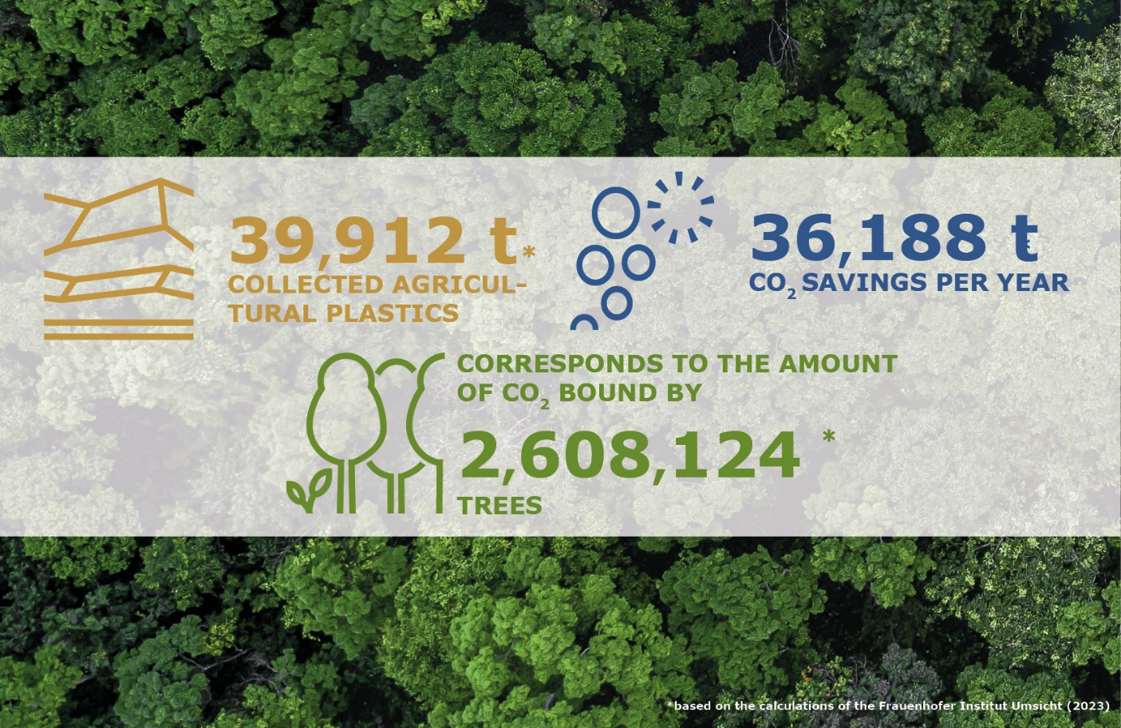****Wiesbaden, Bad Homburg (Germany), June 2024 –* The recovery and recycling system for crop plastics in Germany, ERDE, has announced outstanding achievements in the recycling of agricultural plastics for the year 2023. With a recycling input rate of 71.7% for silage and stretch films and a total CO2 savings of 36,188 tonnes through the collection and recycling of agricultural plastics, the initiative of the IK Industrial Association for Plastic Packaging (<https://kunststoffverpackungen.de/en/>) marks a milestone towards sustainable agriculture.

***Successful commitment to environment and climate: With ERDE, all participants take responsibility for turning used crop plastics into resources. © RIGK***

Following the successful conclusion of its [10-year anniversary](https://www.erde-recycling.de/en/erde-news/erde-initiative-celebrates-its-10th-anniversary-at-agritechnica/) and the [fulfilment of the voluntary commitment from 2019 last year](https://www.erde-recycling.de/en/erde-news/ik-initiative-erde-fulfils-voluntary-commitment-and-collects-over-68-of-silage-and-stretch-films-in-germany/), ERDE has started 2024 with momentum. The current collection campaign is very successful, and the [renewal of the voluntary commitment](https://www.erde-recycling.de/en/erde-news/voluntary-commitment-to-the-bmuv-ik-initiative-erntekunststoffe-recycling-deutschland-erde-renews-its-recovery-commitment/) was already submitted to the BMUV in January. This includes ambitious targets, such as collecting and recycling over 60% of all asparagus films marketed in Germany by 2026 and over 75% of all silage and stretch films by 2027. Concrete collection targets have also been set for other agricultural plastics such as nets, twines, and fleeces. These measures aim to create a comprehensive recycling solution for all crop plastics.

For the completed collection year of 2023, ERDE has now recorded impressive figures: 35,514 tonnes of silage and stretch films were collected. This corresponds to a recycling input rate (net) of 71.7% of the films brought to market, once again surpassing the results of the previous year. Including other collection fractions such as baling twines, bale nets, asparagus/perforated films, fleeces, and mulch/greenhouse films, 39,912 tonnes of agricultural plastics were collected and materially recycled through the ERDE initiative – a clear sign of the system's widespread acceptance among agricultural enterprises, machinery rings, and agricultural traders. In total, the initiative was thus able to achieve a CO₂ saving of 36,188 tonnes through the collection and recycling of agricultural plastics in 2023, equivalent to the CO₂ sequestration potential of approximately 2.6 million trees.

Boris Emmel, System Manager of ERDE, is pleased with the achieved goals and optimistic about the future: *"The figures and successes impressively demonstrate how a voluntary industry initiative can create an effective take-back system that promotes sustainability in agricultural economics. ERDE is a prime example of how manufacturers, agricultural enterprises, collection point operators, and all participants collectively take responsibility. We can therefore look very positively into the future and are confident of achieving our ambitious goals within the framework of our renewed commitment in the coming years."*

As a sign of gratitude and appreciation, system operator RIGK, in cooperation with the Industrievereinigung Kunststoffverpackungen e.V. and the Fraunhofer Institute UMSICHT, issues climate protection certificates to participating manufacturers once a year through the ERDE initiative. Emmel continues: *"RIGK and IK would like to thank everyone involved on behalf of ERDE for their good cooperation and hope for a successful continuation of the trend of increasing greenhouse gas savings in the coming years."*

**About ERDE**

Under the umbrella of the IK Industrievereinigung Kunststoffverpackungen e.V. and in cooperation with RIGK as system operator, ERDE organises the separate return and recycling of used crop plastics such as silage film, stretch film, asparagus film, perforated film, mulch film, non-wovens, bale nets and baler twine via collection partners throughout Germany. Contractors and farmers collect the crop plastics and hand them in bundled - broom-clean and freed of coarse dirt - at a collection point. The return fee is set directly by the [collection point](https://www.erde-recycling.de/en/return-crop-plastics/find-erde-collection-points/). Recycling companies then process the collected material into new plastic raw materials.

More information on members, 100% distribution partners and participating brands can be found [here](https://www.erde-recycling.de/en/take-back-system/100-partner/).  
Any manufacturer or primary distributor of crop plastics who supplies the German market can become a member of ERDE. The following 27 companies assume responsibility for their products and the environment as ERDE members: [APE Europe](https://apeeurope.eu/), [ASPLA S.A.](https://www.aspla.com/gbr/home), [Groupe Barbier](https://www.barbiergroup.com/), [Berry bpi](https://www.berryglobal.com/en/), [Berry Fiberweb France](https://www.berryglobal.com/en/), [CLAAS Vertriebsgesellschaft mbH](https://www.claas.de/), [Cordex - Companhia Industrial Textil S.A.](https://cordex.com/), [Coveris Flexibles Austria GmbH](https://www.coveris.com/), [Daios Plastics S.A.](https://www.daiosplastics.com/), [DUOPLAST AG](https://duoplast.ag/en/homepage/), [KARATZIS S.A.](https://www.karatzis.gr/), [Manupackaging Deutschland GmbH](https://www.manupackaging.com/), [NOVATEX](https://www.tama-ce.de/tag/novatex-rundballennetz/), [PIIppo OYJ](https://www.piippo.fi/), [Plastika Kritis S.A.](https://www.plastikakritis.com/), [Ab Rani Plast Oy](https://www.raniplast.com/), [Reyenvas S.A.](https://www.reyenvas.com/eng/home), [RKW Agri GmbH & Co. KG](https://rkw-group.com/), [Sicor - Sociedade Industrial de Cordoaria S.A.](https://www.sicor.pt/" \t "_blank), [Solplast S.A.](https://solplast.com/eng/home" \t "_blank), [Sotrafa S.A.](https://sotrafa.com/en/" \t "_blank), [Tama Group](https://www.tama.co.il/" \t "_blank), [Tecfil S.A.](https://www.tecfil.pt/" \t "_blank), [Tencate Geosynthetics](https://www.tencategeo.eu/" \t "_blank), [TRIOWORLD GmbH](https://www.trioworld.com/" \t "_blank), [WKI Tegafol Sp. z o.o](https://www.wki.de/wki-tegafol/" \t "_blank) and [XES GmbH](https://xes-nets.eu/" \t "_blank).

**Further information:**

Initiative ERDE / RIGK GmbH  
Boris Emmel  
ERDE System Manager  
Friedrichstr. 6, 65185 Wiesbaden (Germany)  
Phone: +49 611 308600-20  
[emmel(at)rigk.de](mailto:emmel@rigk.de%23)  
[www.erde-recycling.de/en/](https://www.erde-recycling.de/en/)

You can find this press release as a doc file and the images in print-ready resolution for download at https://www.rigk.de/en/worth-knowing/press