Press Release
Save the Date:
4th International Recycling Forum, Wiesbaden
Wiesbaden, June 2024 – RIGK, in cooperation with the European Association of Plastics Recycling and Recovery Organisations (EPRO), cordially invites you to the 4th International Recycling Forum at the Dorint Hotel, Wiesbaden (Germany), scheduled for the 10th and 11th of December 2024. Under the banner "Networking towards a Circular Economy", the forum presents an opportunity to actively shape the future of plastic recycling and to discuss innovative solutions for a sustainable circular economy. Key topics will include the use of recyclates, Design for Recycling, innovative and chemical recycling technologies, as well as the collection and recycling of agricultural plastics. An accompanying exhibition will provide direct contact with leading companies in the industry. The evening event at the Kurhaus Wiesbaden on the second day of the conference will offer ample opportunity for in-depth exchange and networking. The last forum, held in 2019, was attended by 150 participants from 22 countries. The conference language will be English.
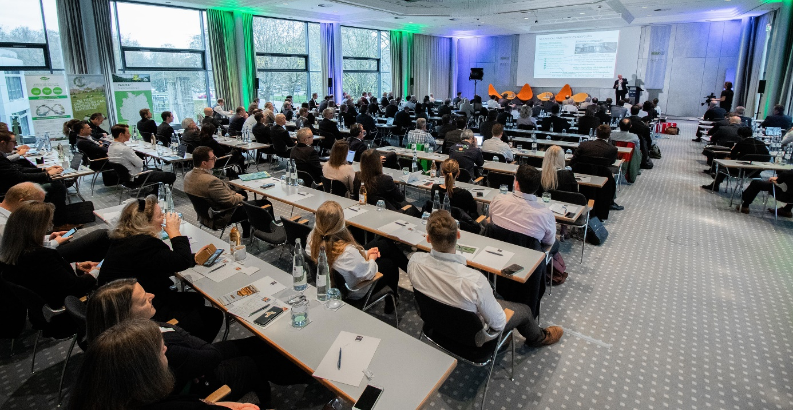
A Glimpse into the Plenum of the 3rd Recycling Forum 2019
Exhibitors and sponsors for 2024 thus far include EREMA Group GmbH, Herbold Meckesheim GmbH, and plastship GmbH. Circular Technology will serve as a media partner, covering the high-caliber program and reporting on the contributions of the speakers.
Jan Bauer, Managing Director of RIGK GmbH, states: "The forum will once again be marked by optimism and innovation – crucial for the advancement of the circular economy. Our mission to promote an efficient cycle for plastics, to reduce CO2 emissions, and to ensure sustainable resource management extends across borders. In light of the EU Packaging Directive PPWR, it is essential to exchange proven practices and best practices in Europe as well as in countries like Canada, New Zealand, and South Africa, for instance, through the EPRO association. This exchange inspires us all and drives environmental protection both globally and locally – a task we aim to further advance together with our partners and forum participants.“
Registration for participation is now open at https://www.international-recycling-forum.de/en/registration. For interested exhibitors, sponsors, or speakers, a few spots are still available at the same web address.

Further Information:
Contact RIGK:  Jan Bauer  Managing Director  +49 611 308600-16  bauer@rigk.de  Mirco Gattinger  Marketing und Social Media Manager  +49 611 308600-39  gattinger@rigk.de | Editorial Contact, Proof Copies:  Konsens PR GmbH & Co. KG  Dr.-Ing. Jörg Wolters  Hans-Böckler-Straße 20  D-63811 Stockstadt am Main (Germany)  Phone: +49 (0) 60 27 99005-13  mail@konsens.de; www.konsens.de

This press information can be found as a docx file and the images in printable resolution for download at https://www.rigk.de/en/worth-knowing/press.

