**PRESS RELEASE**

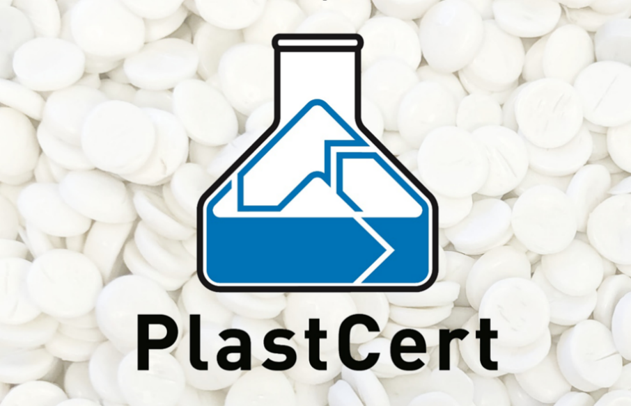RIGK service expanded by PlastCert’s RecyClass Certification and material testing tailored to recyclates

*PlastCert focuses on the complete value-added process of plastic packaging. © RIGK*

Wiesbaden/Germany, July 2023 – As a newly established department of RIGK, PlastCert now certifies plastic packaging and products according to the specifications of the [RecyClass](https://recyclass.eu/) system with the two pillars Recyclability and Recycled Content. Since 2020 RIGK's subsidiary plastship had offered this service which has now been transferred to PlastCert. Both certificates support companies such as plastics processors, packaging manufacturers, brand owners or retailers in documenting their measures to promote sustainability to customers. Another service offered by PlastCert in close cooperation with [plastship](https://plastship.com/) is the determination of recycled material properties as a basis for their use in high-quality products and packaging.

PlastCert's Recyclability Certification tests plastic packaging for its recyclability. It confirms the sustainable use of plastics in the sense of Design for Recycling and thus builds consumer confidence.

By means of the Recycled Content Certification, PlastCert confirms the percentage use of recyclate in plastic packaging and products based on a mass balance according to ISO 15343. This facilitates the traceability of recycled materials along the value chain and promotes their transparent use in products. In countries that already require or plan to require proof of recycled content in packaging, the amount proven via Recycled Content certification reduces related taxation, such as the plastic tax on non-recycled plastic that applies in Spain.

The material testing offered by PlastCert in cooperation with plastship and other partners such as [R.A.M. - Realtime Application Measurement GmbH](http://www.ramgmbh.com/index-de?lang=en), [3S GmbH – Sensors, Signal Processing, System](https://www.3s-ing.de/en/) or [Veridis Technologies B.V.](https://veridis.tech/), which is tailored to the specific requirements of recyclates, serves to qualify them for high-grade applications. In addition to the usual tests for virgin materials, it also covers properties such as odour, impurities, appearance and polymer content.

Konstantin Humm, Manager PlastCert, comments: "RIGK has more than 30 years of experience with take-back systems for packaging and plastics and in-depth know-how about the single-variety collection, take-back and the subsequent recycling processes. With PlastCert, we also support the recycling-friendly design and further improved quality of recyclates. In combination with the RIGK systems and plastship, PlastCert certification advances and sustainably strengthens recycling and the sustainable use of plastics and plastic packaging in line with the circular economy concept."

|  |  |
| --- | --- |
| Contakt PlastCert:  Konstantin Humm Manager PlastCert  Phone: +49 611 308600-91 [humm@rigk.de](mailto:humm@rigk.de)  [PlastCert - Consulting & Certification (rigk.de)](https://www.rigk.de/en/about-rigk/plastcert-consulting-certification) |  |
|  |  |

You can find this press release as a doc file as well as the pictures in printable resolution for download at www.rigk.de/wissenswert/presse.