**Press release**

**"myRecycledContent" – RIGK joins European platform to promote recycled materials in packaging**

*Wiesbaden (Germany), September 2024* – RIGK GmbH has committed itself as the German partner in the ["myRecycledContent"](https://www.myrecycledcontent.eu/)-database – an initiative by European industrial return systems aimed at promoting the use of recycled plastics in industrial and commercial packaging. The platform, available at [www.myrecycledcontent.de/en/](http://www.myrecycledcontent.de/en/), provides a centralised data registry that helps companies find packaging solutions containing certified recycled content.

**What is "myRecycledContent"?**

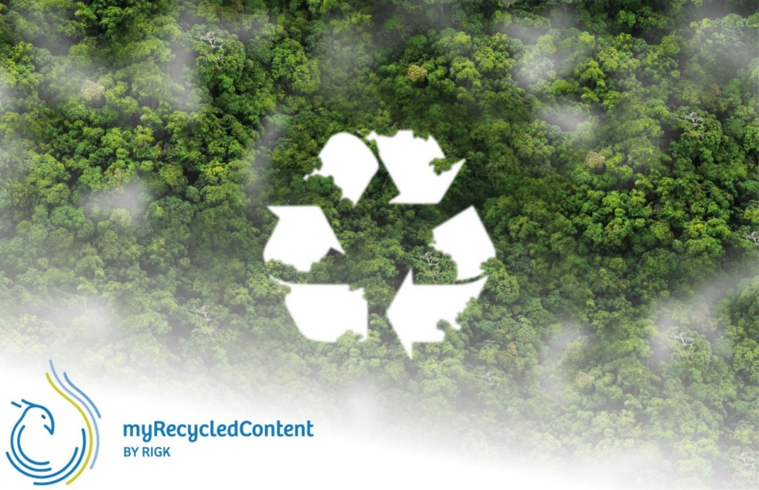"myRecycledContent" connects suppliers and users of packaging that includes recycled plastics, ensuring that all listed products meet the required certifications. Users can freely search for suitable packaging solutions and view supplier contact details via the platform.

***"myRecycledContent by RIGK" now available online. © RIGK***

**An integral approach to the plastics recycling cycle**

For years, RIGK has pursued a holistic approach to plastics recycling, based on national and international cooperation. By participating in "myRecycledContent", RIGK is reinforcing its commitment to closing the plastic loop and promoting sustainability in the packaging industry.

"We are very proud to take this important step towards the future of the packaging industry with the 'myRecycledContent' platform. This initiative helps companies achieve their sustainability goals and prepares them for future regulatory requirements. The European Commission plans to mandate a minimum recycled content of 35% in all industrial plastic packaging by 2030. Thanks to the platform and PlastCert’s certification services, affected companies will be well-prepared to meet these requirements," says Jan Bauer, Managing Director of RIGK GmbH.

In this context, collaboration with RIGK’s subsidiary [plastship GmbH](https://plastship.com/en/) is once again proving valuable. The European procurement and recycling network for plastics offers packaging manufacturers access to a comprehensive database of suitable recyclates, material flows, and delivery options.

**Certification and consultancy**

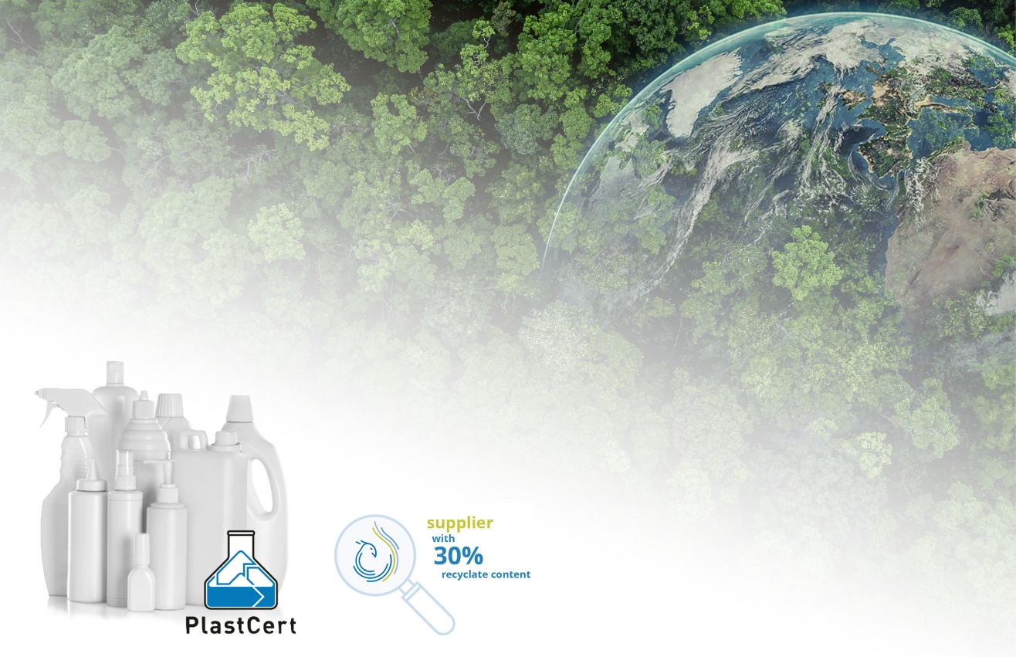In addition to providing information on available packaging solutions, RIGK also offers support for certification of recycled content. Through ist [PlastCert](https://www.rigk.de/en/about-rigk/plastcert-consulting-certification), companies can have their products certified according to [RecyClass](https://recyclass.eu/) standards, covering recyclability, the use of recycled content, and the recycling process.

***PlastCert certifications as part of "myRecycledContent". © RIGK***

"Our certification services are a key part of the platform. They give companies the confidence that their packaging meets the highest standards," explains Konstantin Humm, Manager of PlastCert.

**European collaboration**

The "myRecycledContent" platform is available in Germany and other European countries. Examples of participating countries and companies include EPRO members such as [Valipac in Belgium](https://www.myrecycledcontent.be/) and [TWIICE in France](https://www.myrecycledcontent.fr/en/). This collaboration at the European level promotes the exchange of best practices between countries, thereby strengthening the sustainability of the plastics circular economy.

**Benefits of using recycled plastics**

The use of the platform and the promotion of recycled content in packaging offer numerous advantages:

* **Conservation of fossil resources:** Using recycled materials reduces the depletion of natural resources.
* **Reduction of CO₂ emissions:** Every tonne of recycled plastic saves 3.03 tonnes of CO₂.
* **Energy savings:** Manufacturing plastics from recycled material consumes less energy compared to production from fossil raw materials.
* **Promotion of the circular economy:** Increased demand for secondary raw materials strengthens the recycling industry and drives investment in better recycling processes.

Further information is available at [**"myRecycledContent by RIGK"**](http://www.myrecycledcontent.de/en/).

|  |  |
| --- | --- |
| **Contact RIGK:** Jan Bauer Managing Director +49 611 308600-16 [bauer(at)rigk.de](mailto:bauer@rigk.de)  Konstantin Humm Manager PlastCert  +49 611 308600-91 [humm(at)rigk.de](mailto:humm@rigk.de) | **Editorial contact, specimen copies:** Konsens PR GmbH & Co. KG Dr.-Ing. Jörg Wolters Hans-Böckler-Straße 20 D-63811 Stockstadt am Main (Germany) Tel.: +49 (0) 60 27 99005-13 [mail@konsens.de](mailto:mail@konsens.de); www.konsens.de |

You can find this press release as a doc file and download high-resolution images at https://www.rigk.de/en/worth-knowing/press