**Press Release**

**New in the collection system: Initiative ERDE corporates with AZUD and NETAFIM for drip tapes recycling**

*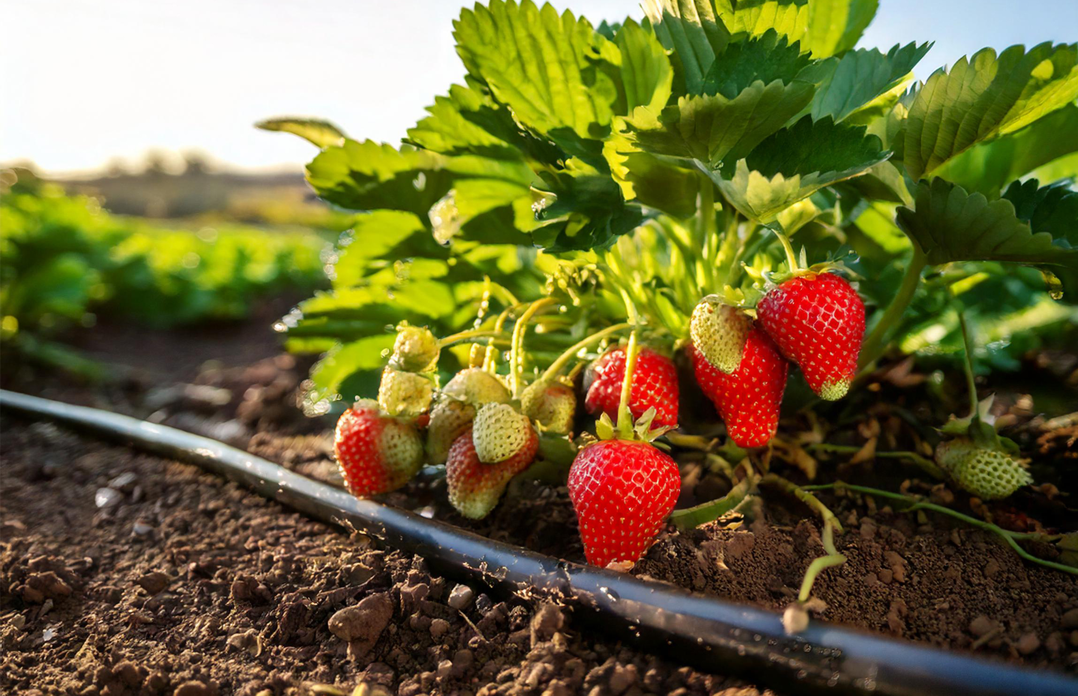Wiesbaden, Bad Homburg, November 2024* – [Initiative ERDE](https://www.erde-recycling.de/en/), a take-back and recycling system for agricultural plastics established by the [Industrial Association for Plastic Packaging](https://kunststoffverpackungen.de/en/) (IK - Industrievereinigung Kunststoffverpackungen e.V.), has expanded its collection and recycling portfolio to include drip tapes. In November 2024, the initiative, in cooperation with [NETAFIM Deutschland GmbH](https://www.netafim.uk/) and [SISTEMA AZUD, S.A.](https://azud.com/en/) – two leading providers of drip irrigation systems – will launch a structured collection program for these critical agricultural plastic products. Initially, this new activity will focus on thin-walled, flexible drip tapes in specific cultivation areas. These pipes will be processed through material recycling to ensure sustainable reuse of the materials and contribute to resource conservation.

***© RIGK***

The decision to include drip tapes in the existing collection system follows positive results from previous pilot projects and feedback from agricultural enterprises. Over recent years, it has become evident that efficient collection and recycling of agricultural plastics provide not only environmental benefits but also economic advantages. For instance, compared to thermal disposal, agricultural enterprises can typically save over half the costs when participating in the recycling program. Boris Emmel, System Manager of the ERDE Initiative, states: “The introduction of drip tapes as a new category represents a significant step toward more sustainable agriculture. Together with participating manufacturers and their distributors, we are now offering agricultural businesses an easy solution for the environmentally responsible takeback and recycling of their used drip tapes.”

The drip tapes will initially be collected based on demand in selected regions at designated collection points or directly through specialized container solutions provided on farms. “We are proud to work with Initiative ERDE to offer farmers a sustainable take-back solution that also protects the environment,” says Marcus Roscher, Managing Director of NETAFIM. “AZUD is also pleased to be part of this important initiative, contributing to sustainable agriculture,” adds Ramón Alcaraz, International Sales Director of AZUD.

To ensure proper recycling, thin-walled drip pipes must meet acceptance criteria such as material purity and the absence of contaminants. Additionally, further discussions are planned to encourage other manufacturers to join the well-established ERDE collection system, which has been operating successfully for over a decade. Expanding participation would enhance the effectiveness and reach of this network. With the introduction of drip tapes as a new category, Initiative ERDE reaffirms its commitment to sustainable agriculture. This measure not only increases recycling rates in the agricultural plastics sector but also contributes significantly to reducing CO₂ emissions.

Initiative ERDE and its members are collectively committed to promoting environmentally friendly removal of agricultural plastics and look forward to the active participation of agricultural businesses in this important project. Farmers can visit the ERDE website anytime to check if the products or manufacturers they purchase are part of Initiative ERDE.

**About ERDE**

Under the umbrella of the IK Industrievereinigung Kunststoffverpackungen e.V. and in cooperation with RIGK as system operator, ERDE organises the separate return and recycling of used crop plastics such as silage film, stretch film, asparagus film, perforated film, mulch film, non-wovens, bale nets and baler twine via collection partners throughout Germany. Contractors and farmers collect the crop plastics and hand them in bundled - broom-clean and freed of coarse dirt - at a collection point. The return fee is set directly by the [collection point](https://www.erde-recycling.de/en/return-crop-plastics/find-erde-collection-points/). Recycling companies then process the collected material into new plastic raw materials.

More information on members, 100% distribution partners and participating brands can be found [here](https://www.erde-recycling.de/en/take-back-system/100-partner/).  
Any manufacturer or primary distributor of crop plastics who supplies the German market can become a member of ERDE. The following 27 companies assume responsibility for their products and the environment as ERDE members: [APE Europe](https://apeeurope.eu/), [ASPLA S.A.](https://www.aspla.com/gbr/home), [Groupe Barbier](https://www.barbiergroup.com/), [Berry bpi](https://www.berryglobal.com/en/), [Berry Fiberweb France](https://www.berryglobal.com/en/), [CLAAS Vertriebsgesellschaft mbH](https://www.claas.de/), [Cordex - Companhia Industrial Textil S.A.](https://cordex.com/), [Coveris Flexibles Austria GmbH](https://www.coveris.com/), [Daios Plastics S.A.](https://www.daiosplastics.com/), [DUOPLAST AG](https://duoplast.ag/en/homepage/), [KARATZIS S.A.](https://www.karatzis.gr/), [Manupackaging Deutschland GmbH](https://www.manupackaging.com/), [Netafim Deutschland GmbH](https://www.netafim.de/), [NOVATEX](https://www.tama-ce.de/tag/novatex-rundballennetz/), [PIIppo OYJ](https://www.piippo.fi/), [Plastika Kritis S.A.](https://www.plastikakritis.com/), [Ab Rani Plast Oy](https://www.raniplast.com/), [Reyenvas S.A.](https://www.reyenvas.com/eng/home), [RKW Agri GmbH & Co. KG](https://rkw-group.com/), [Sicor - Sociedade Industrial de Cordoaria S.A.](https://www.sicor.pt/), [Solplast S.A.](https://solplast.com/eng/home), [Sotrafa S.A.](https://sotrafa.com/en/), [SISTEMA AZUD, S.A.](https://azud.com/en/), [Tama Group](https://www.tama.co.il/), [Tecfil S.A.](https://www.tecfil.pt/), [Tencate Geosynthetics](https://www.tencategeo.eu/), [TRIOWORLD GmbH](https://www.trioworld.com/), [WKI Tegafol Sp. z o.o](https://www.wki.de/wki-tegafol/) and [XES GmbH](https://xes-nets.eu/).

**Further Information:**

Initiative ERDE / RIGK GmbH  
Boris Emmel  
System Manager ERDE  
Friedrichstr. 6, 65185 Wiesbaden (Germany)  
Phone: +49 611 308600-20  
[emmel(at)rigk.de](mailto:emmel@rigk.de%23)  
[www.erde-recycling.de](http://www.erde-recycling.de/en/)/en/

You can download this press release as a Word document, along with high-resolution images suitable for print, at: https://www.rigk.de/en/worth-knowing/press